**Feasibility Study Project**

**3D Printer Factory**

**Supervised by**: Dr. Shady Ali

**Prepared by:**

|  |  |
| --- | --- |
| Name | ID |
| Anas Hesham Mohamed | 33233015 |
| Toka Abdel Gawad Abd Allah | 33233023 |
| Habiba Emad Eldeen Abdallah | 33233029 |
| Hussien Mostafa Mahmoud | 33233031 |
| Norhan Ahmed Saber | 33233097 |

**3D Printer Factory**

* **Idea**:

A factory that buys and manufactures parts of 3D printers and install it together.

* **Pre-Feasibility Study:**

1. **Market FS:**

* After market survey and analysis, the most common used dimensions are:
  + 15 x 15 x 10 (61%)
  + 30 x 30 x 15 (26%)
  + 50 x 50 x 30 (10%)
  + Others (Custom) (3%)
* Demand Forecast:
  + The timing doesn’t affect the demand.
  + The prices are dependent on the dimensions needed and the quality of the parts.
  + The quantity demand is increasing annually.
* Specifications:
  + Structure Materials (Wood or Metal).
  + The Performance of the product.

1. **Legal FS:**

* This Engineering product all the parts meet the country laws, rules, and regulations.
* The brushless DC motors are illegal in Egypt so the product installed with other types.

1. **Technical FS:**
   * The facility will be in 10th of Ramadan city industrial zone The required space is 200 m2 at least.
   * The layout of the facility has 2 floors the ground floor is for operations and working facilities and the inventory, the 2nd floor is for management.
   * The required specialists:
     + Mechanical Engineers
     + Power Engineers
     + Electronics Engineers
     + Software Engineers
     + Technicians

* The required resources:
  + Motors
  + Materials (Metals & Woods)
  + Electronics Components
  + Sales
  + Others

1. **Economic/Financial FS:**

* The cost is determined according to:
  + Rent
  + Operations cost
  + Machines
  + Materials
    - Salaries

1. **Social FS**
   * The cultural and ethical don’t affect the demand of the product.

* **Marketing Study:**

1. **Methods for determining demand:**
   * The demand exhibits no significant trend, cyclical, or seasonal effects.
   * Hence the smoothing methods will be uses.
2. **Types of demand:**

* The demand is active.
* The demand is mostly derived by other demands (Workshops, Plastic Tools, Prototypes, Packaging).
* Part of the demand is independent for scientific and custom purposes.

1. **Analysis of market environment:**

* The market is segmented into 3 categories:
  + Industrial
  + Scientific
  + Educational
* The targeted groups are:
  + The workshops that craft plastic products
  + Other factories
  + Engineers
* **Marketing Feasibility Study**
  1. **Analysis of Demand:**
* Qualitative Analysis of Demand :
  + Factors determining product/service demand:
    - The quality of the delivered 3d printers is an important factor, the demand is directly proportional to the quality.
    - The price: as the product price suits more people and bigger segments of the market the demand increases.
    - The price of the competitors affects the demand of our product, according to the market studies of the competitors:
      * A close-up of a camera

        Description automatically generated with low confidenceGraphical user interface, text, application

        Description automatically generated the price for the desktop 3d printers ranges from 10,030 LE to 24,500 LE
    - The demand is varying according to the price of the associated/complementary products/services like:
      * 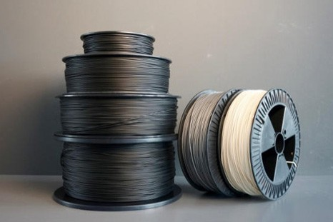Filament prices
      * Maintenance Cost
      * Power consumption
    - The customers income, the profits of the workshops and the factories affects the demand of the 3d printer products (as the profits and income increases the demand increases and vice versa)
    - The trend doesn’t affect our demand
    - The national income and its distribution have a huge impact on the demand as the national income increases our factory can afford more of the tools to, we can deliver more products so the customers could afford to buy more of the product
  + Determining type of demand:
    - After the market studies we did, we assured that our product (3d printer) demand is **active** as the long as there is a desire for 3d printers for the new workshops, industries and college especially engineering also there is a capability for customers to buy it.
    - The demand is mostly **derived** by other demands (Workshops, Plastic Tools, Prototypes, Packaging), while Part of the demand is independent for scientific and custom purposes.
  + Studying characteristics of consumers and segmentation market:

• The market is segmented into 3 categories => the industrial category, the scientific category and the educational category.

• The targeted groups are the workshops that craft plastic products other factories and the engineers with personal use.

* + - 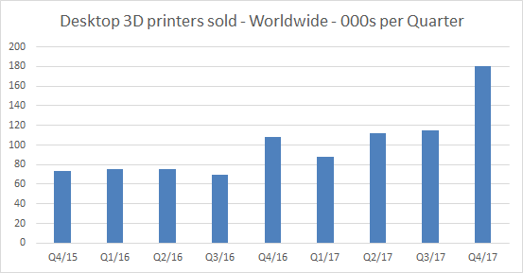in 2017 about half million 3D printers are sold expected to grow up to 100 million in 2030
  + Creating demand for planned services/products:

1. Increasing the rate of consumption of

existing consumers by adding more features to the product (3d printer).

2. Convincing consumers of competitors

products to divert to project products by decreasing the price, increasing the quality and adding more features.

3. Motivating and attract new customers to become consumers for the planned project by promoting the product for the existing workshops and factories

* Quantitative Analysis of Demand

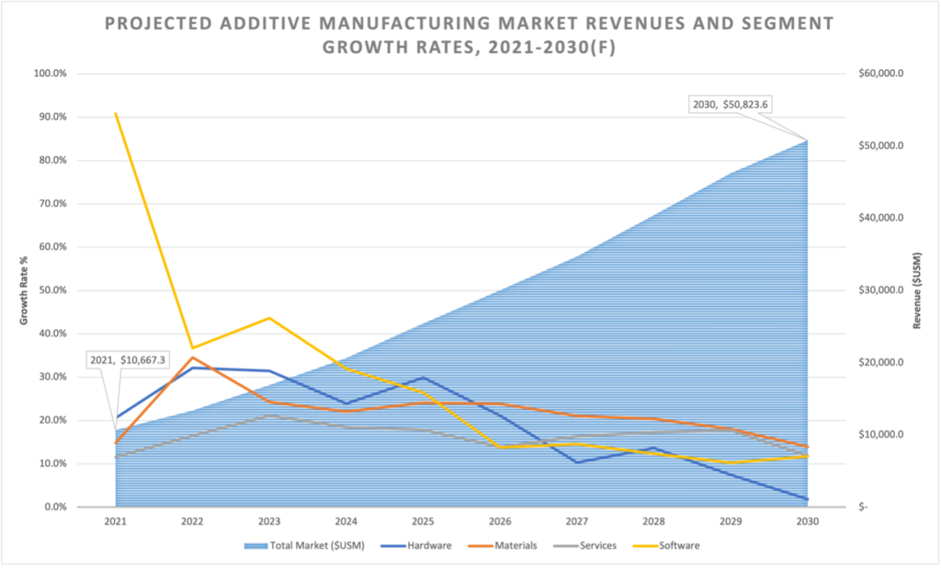

After the studies we did, we found that, in 2021, the 3D printing sector reached $10.6 billion in revenue, excluding the revenues associated with hardware maintenance contracts and post-processing equipment. The firm further projects that AM is expected to grow to over $50 billion by 2030.

* Planning marketing strategies:
  + Marketing environment analysis:
    - Overall marketing environment analysis:

Marketing environment will affect performance of the project. Elements of the overall marketing environment are:

* + - * the social, culture conditions
      * economic indices like:
        + Growth rate and trend of GNP/GDP
        + Inflation rate
        + Interest rates
        + Exchange rates
        + Income levels
      * Technological conditions: we studied the current level of technological aspects in the life and industries, and in the society of the country because they will effect on the distribution and acceptance of the product/project, and also can affect the production of the product (3d printer).

Competitive environment: competition on the sales with other 3d printer companies, as all the competitors are willing to provide alternatives with higher quality, more features and lower price, we also studied the nature or state of the competition in the market, and the competitive strategies of the competitors, their strength and their weaknesses, their services and quality levels.

* + - The project-related environment analysis:
      * Markets:
        + The 3d printer market sales aren’t seasonal affected.
        + The 3d printer market is flourished among the year.
      * Suppliers:
        + We studied the suppliers of raw materials, spare parts, consumable materials, and finished parts and analyzed in order to prevent supplies shortages and to realize supply stability. Some of the desirable suppliers’ attributes
        + Stability of suppliers’ production line is an important factor as our project consists of many complementary parts.
  + Developing marketing strategies
    - Product strategies:

We planned to add:

* A trademark
  + - * a good packaging to the product
      * a product instruction

in order to meet the commercial standards.

* Price strategies:

In conclusion, the price strategy must be relative suitable considering other offered prices in the markets for the same products, customers’ acceptance and supply-demand conditions.

Pricing: the decisions of the pricing include the specifications of discounts, prices of installment sales, fairs prices, etc.………

* Promotion Strategy:
  + Advertising: the direct advertising isn’t suitable for our project because we aren’t targeting individuals, we target organizations.
  + Sales Promotion: any other persuasive way like discounts, coupons and product brochures.
  + Public relations: and unpaid mention of a company, brands or product by the media.

* **Financial Feasibility Study**

Our financial structure depends on:

* Loan policies (local and international banking system)
* The nature of our project
* The taxes and the regulations of the Egyptian government.
* We are willing to take some risks according to our risk analysis of the project
* **Economic Feasibility Study**

we evaluated our project economically based on some economic indicators like:

* Payback period (PBP): our project has a medium payback period
* Return of investment (ROI): our studies determined that the Return of investment of our project will be around 3 years
* **Technical Feasibility Study**

We decided to locate our project facilities in the industrial zone, because it’s a feasible site as mentioned before.

The technologies used for the project is available as we have some domestic and exported technologies, the exported technologies are open source:

* Marlin
* Pronterface.
* GRBL

Our project technical FS had 4 stages:

* 1. Studying and analyzing project site
  2. Planning the process of manufacturing the 3d printer
  3. Planning the resources requirements of the 3d printer manufacturing process
  4. Estimating the cost of our project